Intro to Databases – Lab Report 02
Student Name: Qasim bin Mehmood
Student ID: AS25SYD006
Course: Intro to Databases
Date: June 3. 2026

Submitted to: Prof. Dinakar Bhotta

Table of Contents
1. First Name, Last Name Concatenation 3
2. Selecting Distinct Amount 3
3. Selecting Distinct Rental and Replacement Cost 4
4. First Name, Last Name 4
5. Selecting with Filter 5

1. First Name, Last Name Concatenation
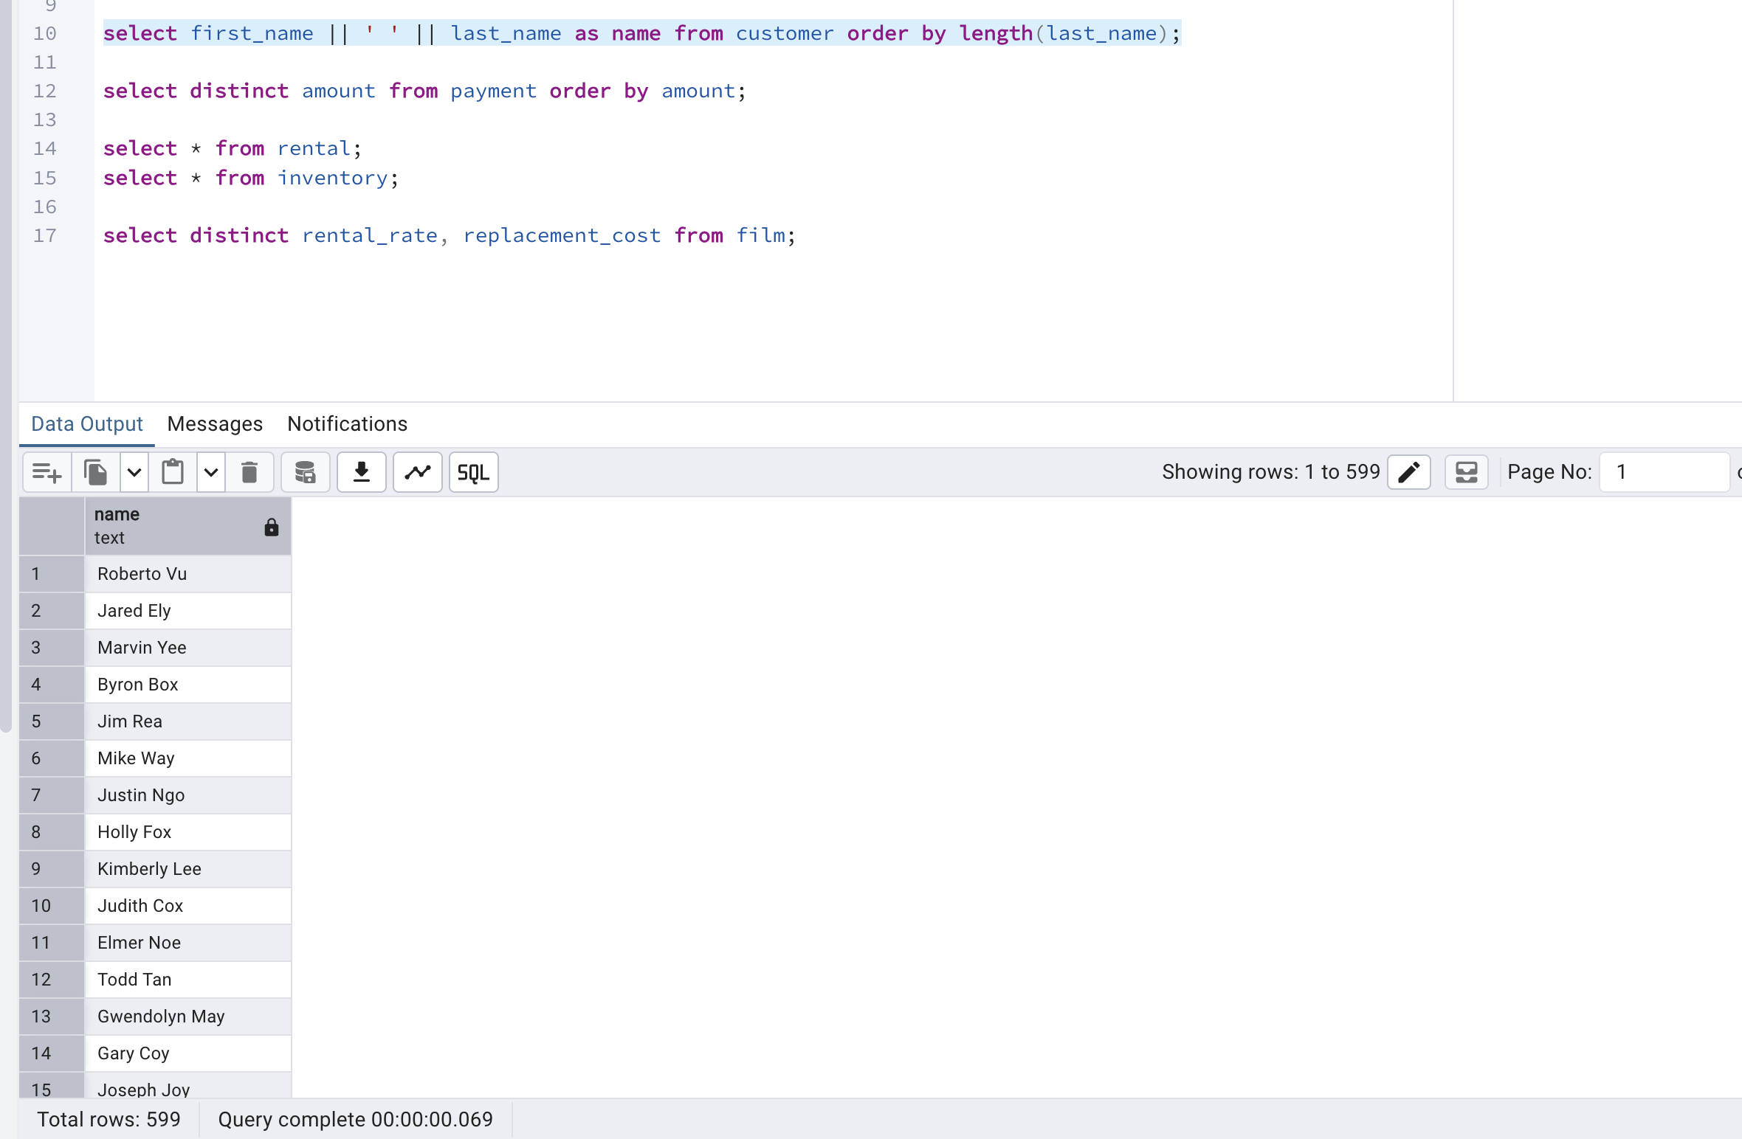

2. Selecting Distinct Amount
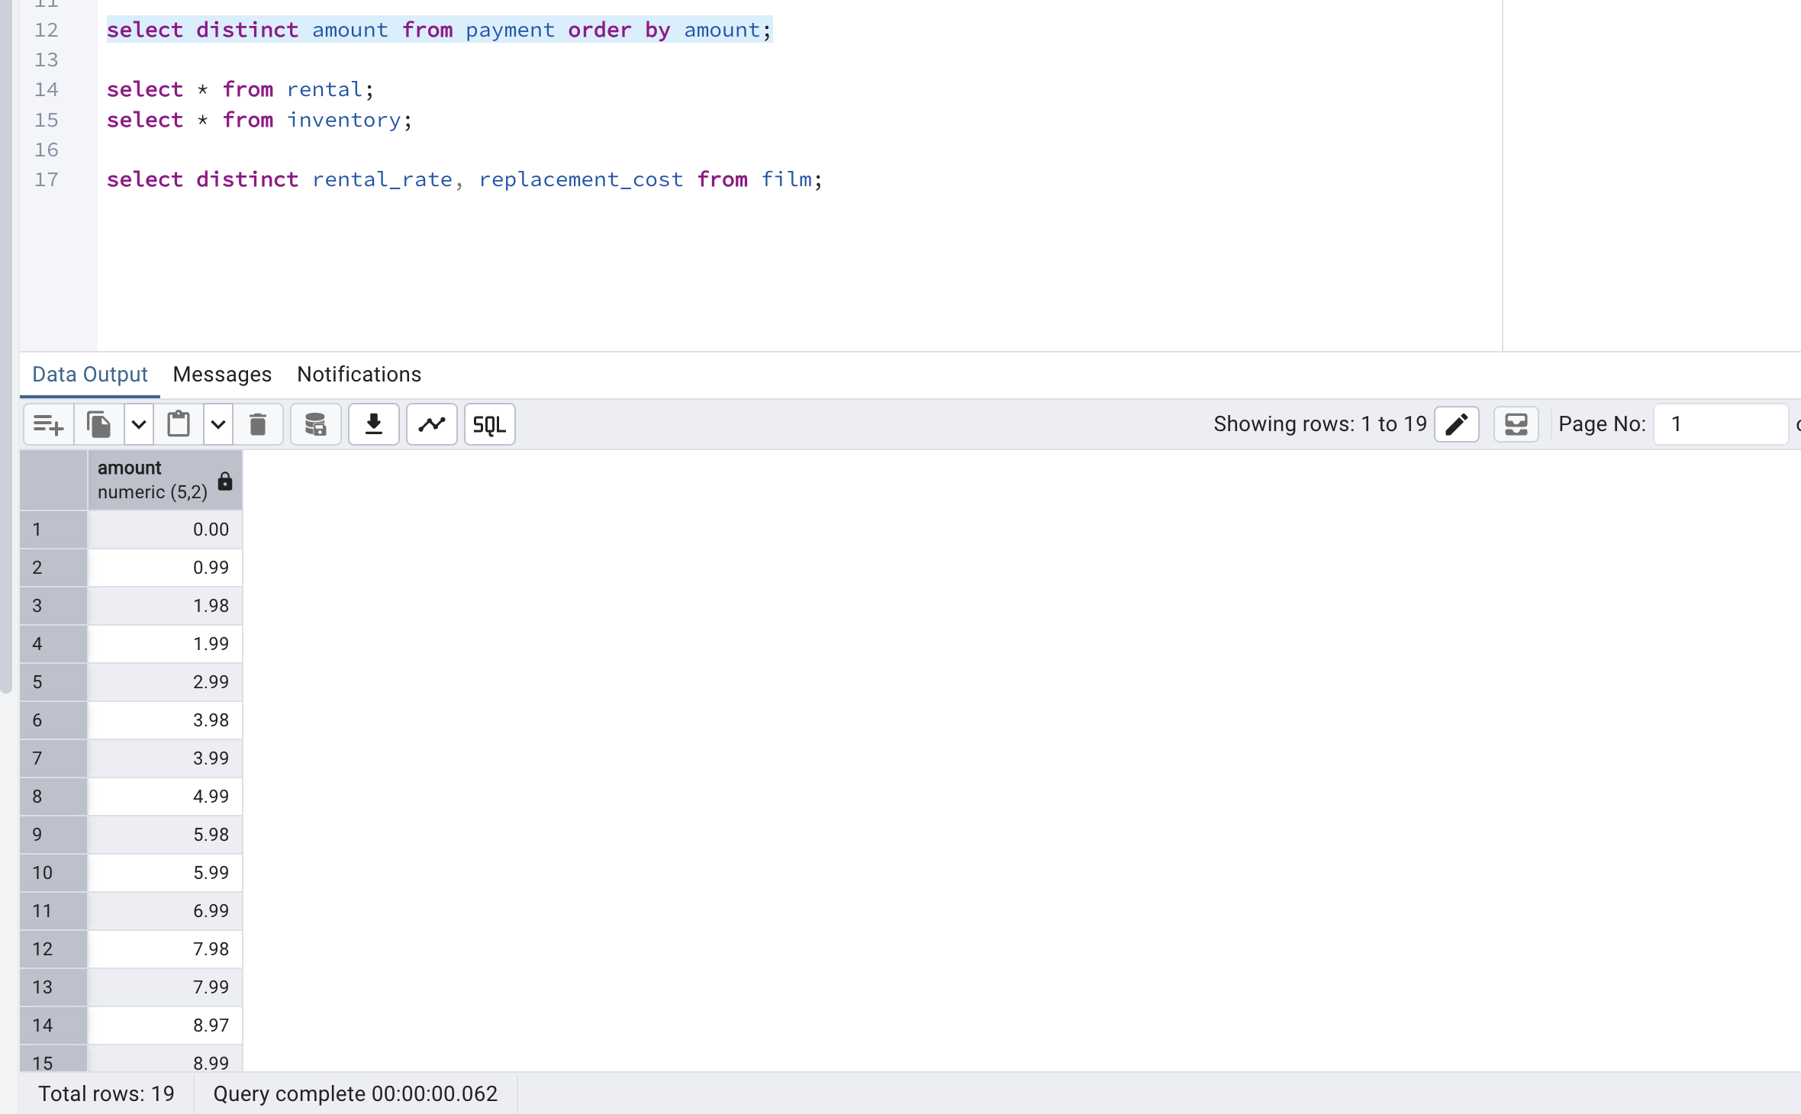

3. Selecting Distinct Rental and Replacement Cost
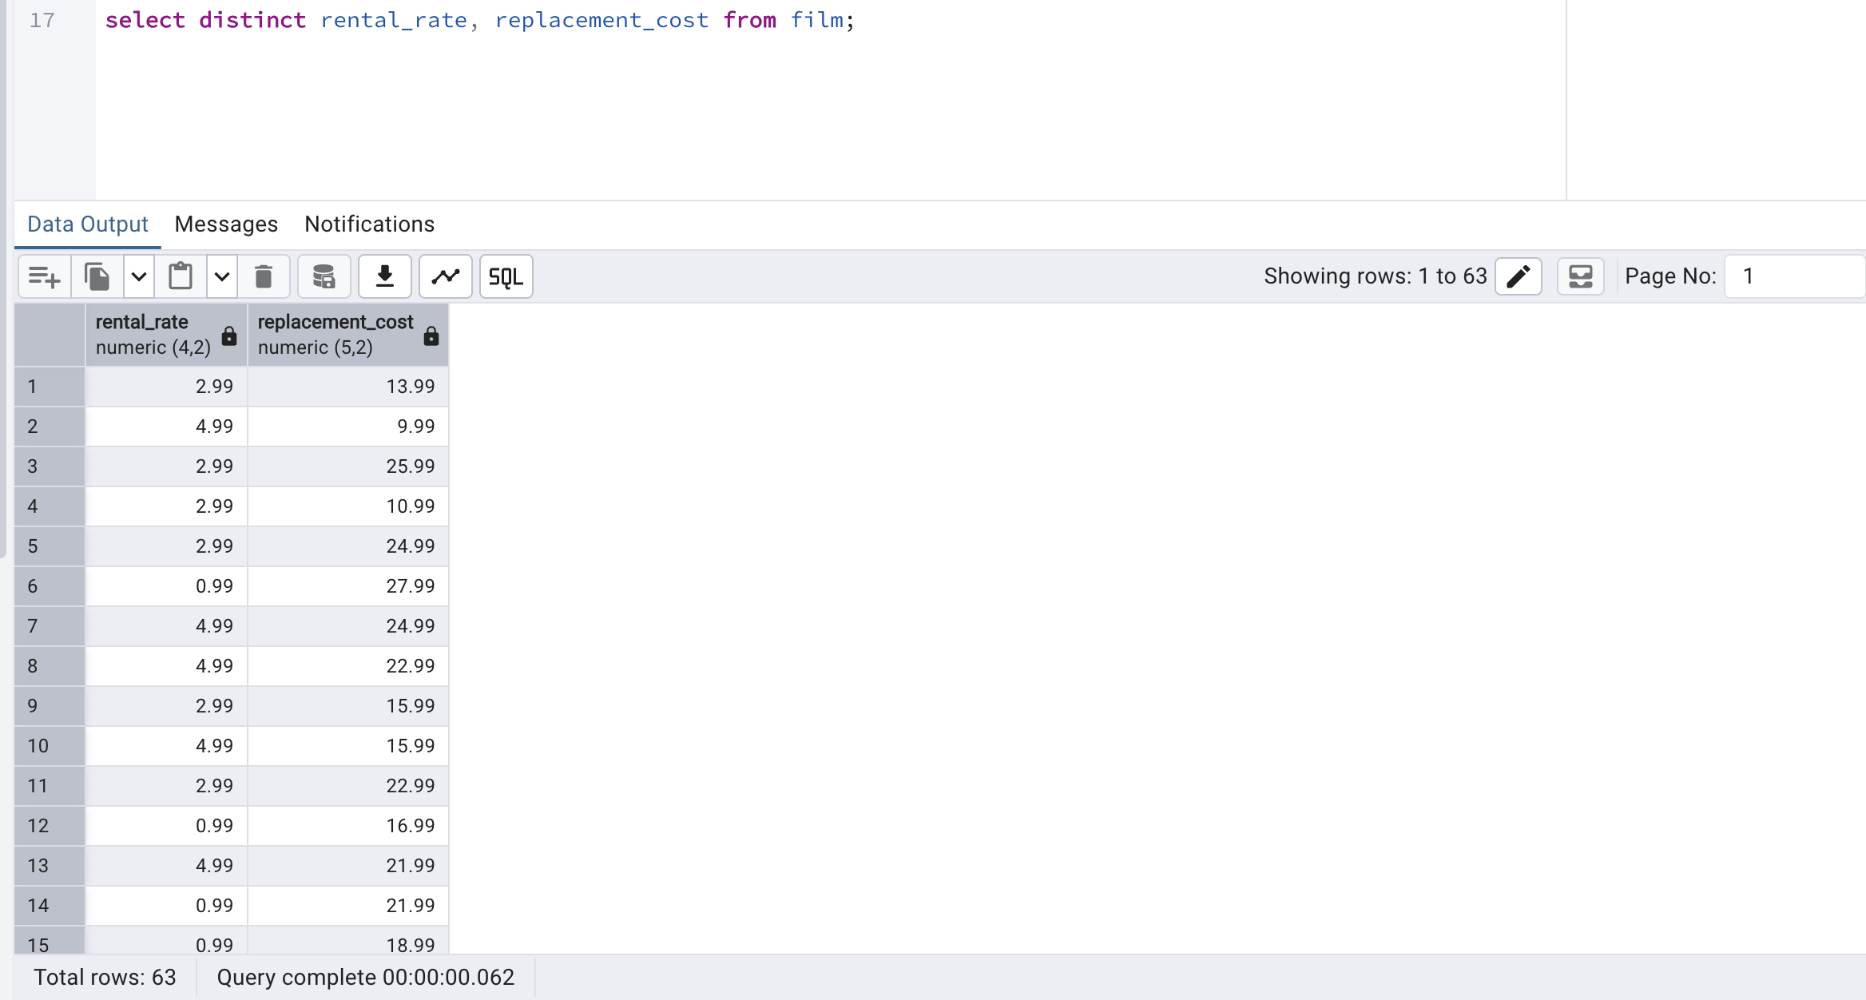

4. First Name, Last Name
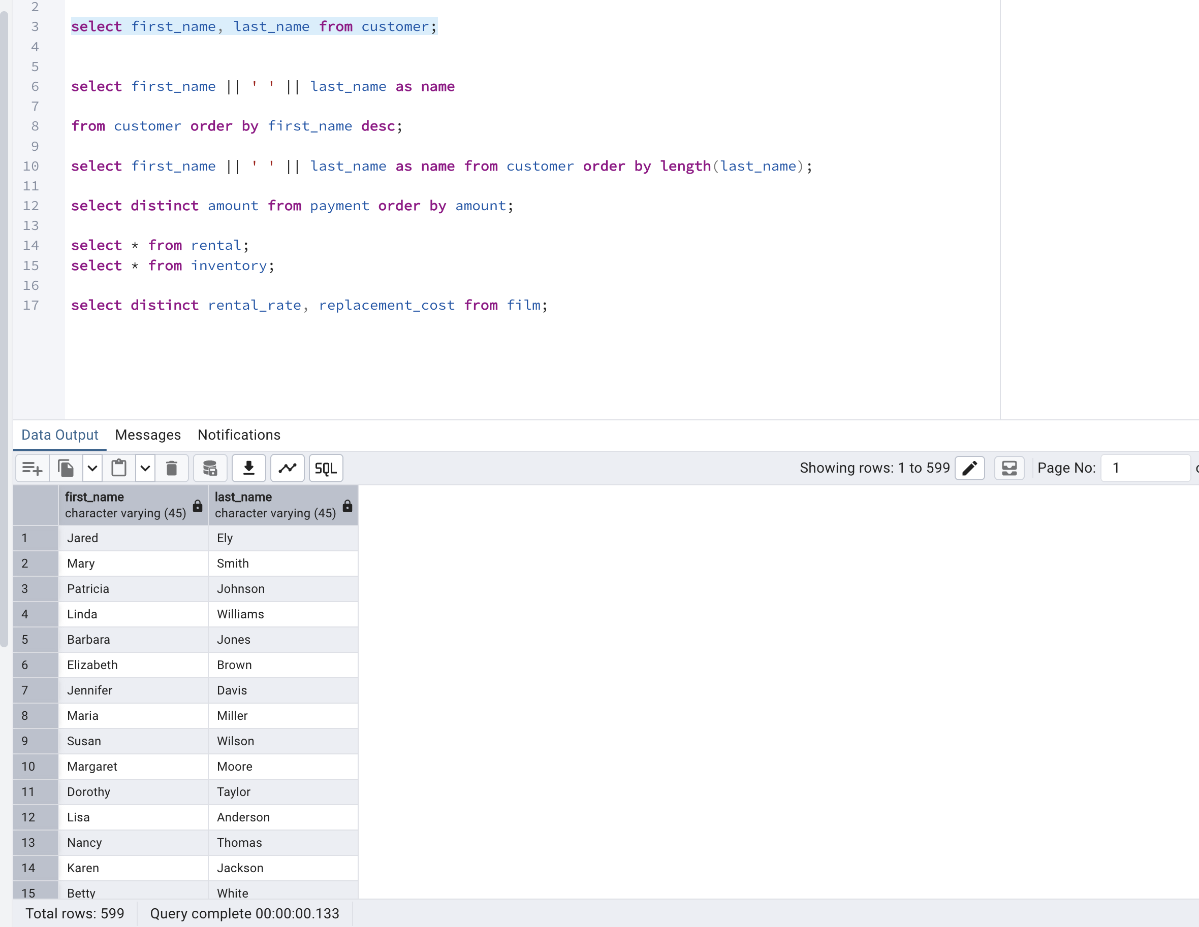

5. Selecting with Filter

